FORM 2
THE PATENTS ACT, 1970
(39 of 1970)
&
THE PATENTS RULES, 2003
COMPLETE SPECIFICATION
(See Section 10 and Rule 13)
1. TITLE OF THE INVENTION:
S.A.F.E.-DRONE - Swarm-based Autonomous Field-clearance & Escort Drone System
2. APPLICANT(S):

(a) | Name | Gujarat Council on Science and Technology (GUJCOST)
(b) | Nationality | Indian
(c) | Address | Block B, 7th Floor, M. S. Building, Nr. Pathikashram, Sector 11,  Gandhinagar, Gujarat – 382011, India
(a) | Name | Indian Institute Of Technology, Bhubabneswar
(b) | Nationality | Indian
(c) | Address | Indian Institute Of Technology, Bhubaneswar, Argul (Jatni),  Khordha, Odisha, 752050

3. PREAMBLE TO THE DESCRIPTION
The following specification particularly describes the invention and the manner in which it is to be performed.

4. DESCRIPTION

FIELD OF THE INVENTION
[0001] The present invention relates generally to the field of autonomous robotic systems and unmanned aerial vehicles (UAVs). More particularly, the invention relates to a coordinated autonomous drone swarm system configured for landmine detection and hazardous area mapping. The system utilizes a "Trident" formation of Micro-Aerial Vehicles (MAVs) employing low-resolution thermal imaging sensors (e.g., MLX90640) and a discrete "step-and-stare" navigation protocol to identify buried plastic mines based on thermal inertia differentials.
[0002] The invention is industrially applicable in defense and humanitarian sectors for the safe, remote detection of Improvised Explosive Devices (IEDs) and landmines. Advantages of the present invention include the ability to deploy a low-cost, self-healing swarm that eliminates the risk to human deminers, provides real-time dynamic mapping of hazardous zones, and utilizes decentralized edge processing to function effectively in communication-denied environments without reliance on expensive, high-resolution thermal cameras or heavy Ground Penetrating Radar (GPR) equipment.

BACKGROUND OF THE INVENTION
[0003] Status of the Technology: Landmines and unexploded ordnance (UXO) pose a persistent global threat. The current status of technology for detecting these hazards primarily relies on manual demining squads equipped with handheld metal detectors or prodders. This manual approach is extremely slow, labor-intensive, and carries a high risk of fatality. More advanced solutions include single Remotely Operated Vehicles (ROVs) or heavy ground robots equipped with GPR or high-fidelity thermal cameras.
[0004] Closest Technological Solution: The closest existing technological solutions involve single-agent UAVs equipped with high-resolution thermal or multispectral cameras that scan areas in continuous flight. Some research exists on using drone swarms for general surveillance, but these typically rely on centralized ground control and high-bandwidth video streaming.
[0005] Limitations of Existing Systems: However, these existing systems suffer from significant technical limitations. Manual demining is inherently dangerous. Single-agent robotic systems lack redundancy; if the robot experiences a battery or sensor failure, the entire mission is aborted. Furthermore, detecting buried plastic mines (which have low metal content) is difficult for standard metal detectors. While thermal imaging can detect the heat signature difference of buried objects, high-resolution thermal cameras are prohibitively expensive for large-scale deployment. Additionally, continuous flight motion introduces "motion blur" and noise into thermal images from low-cost sensors, leading to high false-positive rates. Finally, existing swarms often lack robust "self-healing" capabilities, meaning the loss of one drone creates a gap in the scan coverage.

OBJECT OF THE INVENTION
[0006] It has already been proposed to use unmanned vehicles for mine detection to reduce human risk. However, these solutions do not address the need for a redundant, low-cost swarm architecture capable of high-accuracy detection using low-resolution sensors.
[0007] The principal object of this invention is to provide an autonomous drone swarm system arranged in a "Trident" formation, comprising a Master relay drone and multiple Slave sensing drones, which ensures optimal communication stability and scan area coverage.
[0008] Another object of this invention is to implement a discrete "step-and-stare" navigation logic, wherein each sensing drone pauses at specific coordinates to capture a burst of frames (e.g., 16-20 frames) for temporal averaging, thereby mitigating sensor noise and motion blur inherent in low-cost thermal sensors.
[0009] A further object of this invention is to utilize a thermal inertia differentiation method that distinguishes buried mines from surface clutter (such as rocks) based on specific temperature thresholds (e.g., approximately 0.6°C differential for mines versus >1.5°C for surface objects) and anomaly size.
[0010] A further object of this invention is to provide a "Two-Stage Verification" maneuver, wherein a drone autonomously descends from a primary search altitude (approx. 1.5 meters) to a confirmation altitude (approx. 0.5-0.7 meters) to verify high-probability targets before resuming its path.
[0011] A further object of this invention is to incorporate a decentralized "self-healing" formation logic based on an Artificial Potential Field (APF) or "Atom Separation" model, which automatically reconfigures the remaining drones to fill coverage gaps if a swarm member fails or returns to launch.
[0012] Yet another object of this invention is to ensure mission continuity through a Dynamic Master Succession protocol, wherein the swarm autonomously promotes a Slave drone with the highest battery capacity to the Master role in the event of a Master drone failure.

SUMMARY OF THE INVENTION
[0013] The present disclosure provides an autonomous drone swarm system for landmine detection and hazardous area mapping. The system comprises a plurality of unmanned aerial vehicles (UAVs) arranged in a "Trident" formation, consisting of a Master UAV and at least three Slave UAVs. The Master UAV operates as a mobile communication hub and formation anchor, generating a localized wireless network to coordinate the swarm.
[0014] The Slave UAVs are configured to navigate in parallel search corridors using a discrete "step-and-stare" movement pattern. Unlike continuous scanning systems, the Slave UAVs hover at discrete waypoints to capture multiple thermal frames (e.g., 16-20 frames) using low-resolution sensors (e.g., MLX90640). These frames are processed onboard to reduce sensor noise through temporal averaging.
[0015] The system distinguishes buried mines from surface clutter based on thermal inertia physics, specifically identifying anomalies with a temperature differential of approximately 0.6°C relative to the soil. Upon detection, a Slave UAV executes a two-stage verification maneuver, autonomously descending from a search altitude (approx. 1.5 meters) to a confirmation altitude (approx. 0.5-0.7 meters) for high-resolution verification.
[0016] Furthermore, the system incorporates a decentralized "self-healing" capability using an Artificial Potential Field (APF) model to mimic atomic separation forces. If a Slave UAV fails, the remaining UAVs automatically adjust their lateral formation to maintain contiguous search coverage. The system also includes a Dynamic Master Succession protocol to ensure mission continuity if the Master UAV fails.
BRIEF DESCRIPTION OF THE DRAWINGS
[0017] The features of the invention are described with reference to the following drawings, wherein like elements are labeled similarly:
[0018] FIG. 1 illustrates a front schematic view of the Micro-Aerial Vehicle (MAV) showing the payload configuration, including the thermal camera and processing unit.
[0019] FIG. 2 illustrates the overall system architecture, depicting the command hierarchy between the User, Master Drone, and Slave Drones.
[0020] FIG. 3 illustrates the "Trident" formation and the discrete "step-and-stare" search corridors utilized during the mission.
[0021] FIG. 4 illustrates the "Self-Healing" reconfiguration logic, depicting the lateral shift of Slave Drones to close a coverage gap upon a single unit failure.
[0022] FIG. 5 illustrates the "Two-Stage Verification" maneuver, showing the autonomous descent from search altitude to confirmation altitude over a detected anomaly.
[0023] FIG. 6 is a flowchart illustrating the operational logic of the mission, including the decision loops for anomaly detection and drone failure.
[0024] FIG. 7 illustrates the communication topology, detailing the Wi-Fi mesh network links between the Master and Slave nodes.
DETAILED DESCRIPTION OF THE INVENTION
[0025] System Overview The present invention discloses a coordinated autonomous swarm of Micro-Aerial Vehicles (MAVs) designed for the non-invasive detection of buried plastic landmines. As illustrated in FIG. 1, each MAV is engineered with a maximum takeoff weight of approximately 600–800 grams. The frame supports a vertically stacked payload including a thermal imaging sensor, specifically an MLX90640 (32x24 resolution), and a single-board computer (e.g., Raspberry Pi 4), optimized for a flight endurance of approximately 15 minutes per sortie.
[0026] Swarm Architecture (FIG. 2 & FIG. 7) The system operates on a hierarchical network architecture referred to herein as the "Trident" formation. As shown in FIG. 2, this structure consists of one Master Drone (200) positioned at the rear-center and three Slave Drones (300a, 300b, 300c) deployed in a parallel front-line formation. The Master Drone (200) functions as the primary communication relay between the Human Operator (100) and the swarm. Referring to FIG. 7, the Master generates a localized Wi-Fi Mesh Network via Backhaul Links (600) to facilitate low-latency inter-drone data exchange. To ensure redundancy, the Slave Drones maintain Lateral Links (610), allowing data to hop between nodes if the primary link is obstructed.
[0027] Navigation Protocol: "Step-and-Stare" (FIG. 3) To accommodate the limitations of low-resolution thermal sensors, the invention employs a discrete motion protocol. As illustrated in FIG. 3, the Slave Drones (300a-c) advance along parallel Search Corridors (310) in the Direction of Motion (330). Instead of continuous flight, which induces motion blur, the MAV navigates to a waypoint, enters a stable hover, and captures a burst of 16–20 frames. The onboard processor performs temporal averaging on these frames to eliminate Fixed Pattern Noise (FPN) before proceeding to the next waypoint.
[0028] Detection Physics and Verification (FIG. 5) The detection logic relies on thermal inertia differentials (ΔT). Buried plastic landmines are detected based on a specific variance (typically ΔT≈0.6∘C). To validate potential targets, the system utilizes a "Two-Stage Verification" logic shown in FIG. 5. First, the drone scans at a Search Altitude (400) of typically 1.5 meters. Upon detecting a thermal Anomaly (420), the drone pauses its linear path and descends to a Confirmation Altitude (410) of approximately 0.5–0.7 meters. This descent significantly improves spatial resolution for a confirmation scan before the drone re-ascends.
[0029] Self-Healing and "Atom Separation" Logic (FIG. 4) The formation integrity is maintained via an Artificial Potential Field (APF) algorithm. As depicted in FIG. 4, if a Failed Drone (500) occurs (e.g., Unit 300b fails due to battery depletion), the repulsive force associated with that node disappears. The logic automatically triggers the neighboring Slave Drones (300a, 300c) to execute a Reconfiguration Maneuver (510), shifting laterally inward to close the coverage gap. This ensures that the search field remains contiguous even after a unit loss.
[0030] Operational Logic (FIG. 6) The autonomous decision-making process is summarized in the flowchart of FIG. 6. The system continuously loops through the "Step-and-Stare" scan until an interrupt occurs. The primary interrupts are "Anomaly Detected" (triggering the verification of FIG. 5) or "Drone Failure Detected" (triggering the self-healing of FIG. 4). To ensure robust command, the Master Drone broadcasts a "Keep-Alive" heartbeat signal at 1.0 Hz. If this signal ceases, a "Dynamic Succession" protocol promotes the Slave Drone with the highest residual battery to the Master role.
[0031] User Interface The Human Operator (100) interacts with the system via voice commands (e.g., "Start," "Return") relayed to the Master Drone (200). The detection data is aggregated and visualized as a real-time Grid Map on the user's device, marking "Safe Zones" versus "Confirmed Hazards" based on the validated thermal data.
We Claim:
1. An autonomous drone swarm system for landmine detection and hazardous area mapping, the system comprising: a plurality of Micro-Aerial Vehicles (MAVs) arranged in a hierarchical formation; said formation comprising a single Master UAV (200) positioned as a rear anchor and a plurality of Slave UAVs (300a, 300b, 300c) positioned in a forward parallel array; wherein said Master UAV (200) comprises a wireless communication module configured to generate a localized mesh network (600) for inter-agent data exchange; and wherein each said Slave UAV (300) comprises a low-resolution thermal imaging sensor and an onboard processor configured to execute a discrete "step-and-stare" navigation protocol.
2. The system as claimed in claim 1, wherein said "step-and-stare" navigation protocol comprises the Slave UAV navigating to a specific waypoint, maintaining a stable hover, and capturing a burst of 16 to 20 thermal frames to perform temporal averaging for noise reduction before advancing to a subsequent waypoint.
3. The system as claimed in claim 1, configured to detect buried hazards based on thermal inertia differentials, wherein the system identifies anomalies exhibiting a temperature differential (ΔT) of approximately 0.6∘C relative to the surrounding terrain while filtering out surface clutter exhibiting a ΔT greater than 1.5∘C.
4. The system as claimed in claim 1, further configured to execute a "Two-Stage Verification" maneuver upon detecting a thermal anomaly (420), wherein a specific Slave UAV (300) autonomously descends from a primary search altitude (400) of approximately 1.5 meters to a confirmation altitude (410) of approximately 0.5 to 0.7 meters to capture high-resolution thermal data.
5. The system as claimed in claim 1, wherein the swarm utilizes a decentralized "Self-Healing" formation logic based on Artificial Potential Fields (APF), wherein upon the failure of a specific Slave UAV (500), the remaining Slave UAVs (300a, 300c) autonomously execute a lateral reconfiguration maneuver (510) to close the search coverage gap.
6. The system as claimed in claim 1, further comprising a Dynamic Master Succession protocol, wherein upon the failure of the Master UAV (200), the system autonomously designates the Slave UAV with the highest remaining battery capacity to assume the role of the Master UAV.

Dated 16th February 2026

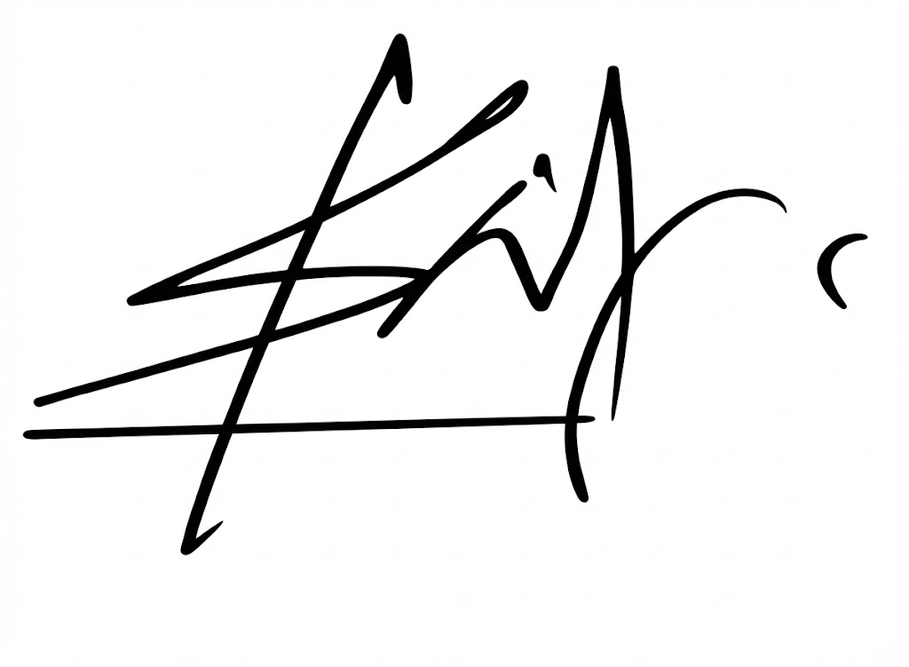

Prof. Shantanu Pal  Dean Under Graduate  Indian Institute of Technology,  Bhubaneswar | Dr. Narottam Sahoo  Advisor and Member Secretary  Gujarat Council on Science and Technology  Dept. of Science and Technology, GoG.

ABSTRACT
TITLE: S.A.F.E. (Swarm-Assisted Field Escort) System for Minefield Detection and Safe Human Navigation
The present invention discloses an autonomous drone swarm system for detecting buried mines using low-resolution thermal imaging. The system utilizes a "Trident" formation comprising a Master relay drone and multiple Slave sensing drones. The drones employ a discrete "step-and-stare" navigation protocol to capture temporally averaged thermal data, filtering sensor noise. A decentralized "Atom Separation" logic allows the swarm to self-heal and reconfigure formation upon unit failure. The system distinguishes mines from clutter using thermal inertia differentials and verifies targets through an autonomous two-stage descent maneuver, providing a real-time dynamic grid map to the user.

Dated 16th February 2026


Prof. Shantanu Pal  Dean Under Graduate  Indian Institute of Technology,  Bhubaneswar | Dr. Narottam Sahoo  Advisor and Member Secretary  Gujarat Council on Science and Technology  Dept. of Science and Technology, GoG.

